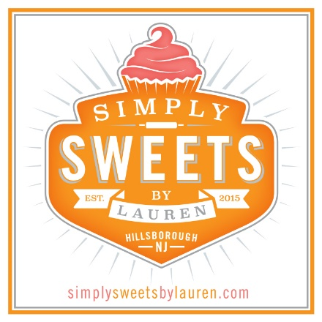
Cake Flavors
Welcome! These are our cake flavors. If you are here to choose flavors for your wedding cake TASTING:
- Choose up to 3 CAKE FLAVORS.
- Choose up to 5 FILLING FLAVORS and/or PREMIUM FLAVORS (these go between the cake and buttercream layers)
Our tastings are a deconstructed (mix and match, with un-iced cake and fillings on the side) so you need not pair the cake with fillings.

CAKE FLAVORS
vanilla bean
chocolate
fun-fetti
banana*
almond
chocolate chip
carrot*
lemon
vanilla oreo
chocolate oreo

FILLING | FLAVORS
vanilla | whipped ganache
chocolate | almond
salted caramel | fun-fetti
lemon | cream cheese*
oreo cookie  cookie dough  white chocolate  pistachio | coconut  coffee  mocha  cannoli*

PREMIUM FILLINGS/ADDITIONS
raspberry preserves
strawberry*
ganache
lemon curd*
blueberry compote*
salted caramel swirl
ICING FLAVORS
vanilla bc
chocolate bc
ganache
fondant

*Seasonal or Specialty Flavors available for an additional charge
………………………………………………………………………………………………………………………………………………………………….
284 Route 206 BLDG E Suite 11
Hillsborough, NJ 08844
908.295.0435

